**DAILY ONLINE ACTIVITIES SUMMARY**

|  |  |  |  |
| --- | --- | --- | --- |
| **Date:** | 17/06/2020 | **Name:** | Krishnitha |
| **Sem & Sec** | 4th sem, A Section | **USN:** | 4AL18CS039 |
| **Online Test Summary** | | | |
| **Subject** | NA | | |
| **Max. Marks** | NA | **Score** | NA |
| **Certification Course Summary** | | | |
| **Course** | Application Developer | | |
| **Certificate Provider** | AWS Educate | **Duration:** | 4 hrs |
| **Coding Challenges** | | | |
| **Problem Statement:**  Write a C Program to Count numbers that don’t contain 3. | | | |
| **Status:** Executed | | | |
| **Uploaded the report in GitHub** | | YES | |
| **If yes Repository name** | | <https://github.com/krishnitha/C-coding> | |
| **Uploaded the report in slack** | | YES | |

**Certification Course Details:**

Today I have continued the course “Application Developer” by AWS Educate. In this course today I learnt about ‘Data and Databases: Structures, Relational and Non-Relational’. In this module I learnt about Data Structures and their functionalities. I have also completed this module by clearing the assessment.

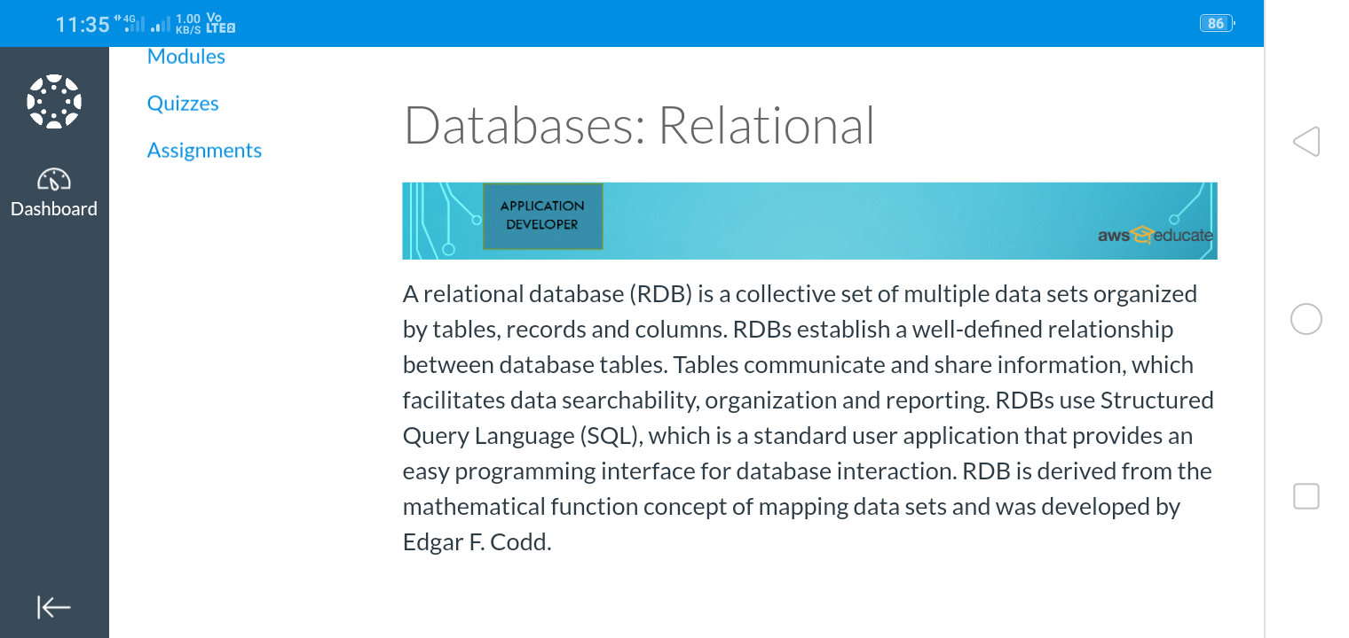

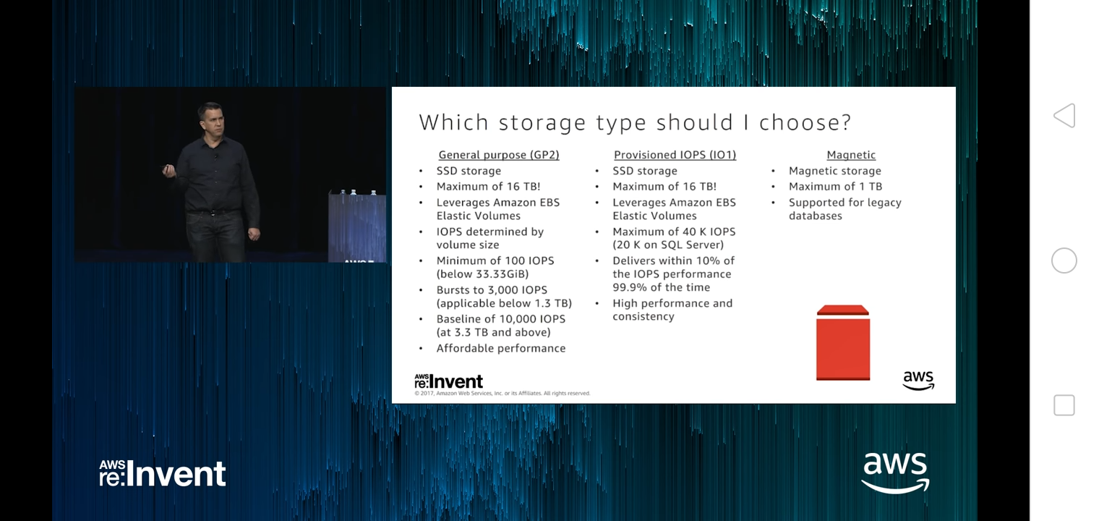

**Coding Challenges Details:**

**Problem:** Write a C Program to Count numbers that don’t contain 3

Given a number n, write a function that returns count of numbers from 1 to n that don’t contain digit 3 in their decimal representation.

**Examples:**

Input: n = 10

Output: 9

Here input is 10 means the numbers within 10 are 1,2,3,4,5,6,7,8,9,10 in this series 3 occurs only 1 times so answer is 9

More examples

Input: n = 45

Output: 31

// Numbers 3, 13, 23, 30, 31, 32, 33, 34,

// 35, 36, 37, 38, 39, 43 contain digit 3.

Input: n = 578

Output: 385**Solution:** Uploaded it in GitHub

